Group Number: _____ Date(s) and Time(s) of Drive Around: ______________ Group Leader: _______________
Group Members: (names-all) ___________________________________________________________________________
Zip Code 3301
County: Broward County
Neighborhood: Colee Hammock
Post Office City: Fort Lauderdale, FL
Notes and Pictures
Boundaries:
Are the boundaries geographical, political, or economic?
Do neighborhoods have names? Are there sub-communities? How are these identified?
Notes: Fort Lauderdale is next to Colee Hammock. The neighborhood are geographical. There are mix of real estate ranging from a single family, condominiums, townhouses and luxurious condominiums. The range of homes available are Art Deco, contemporary, Mediterranean, Cape Code and more.
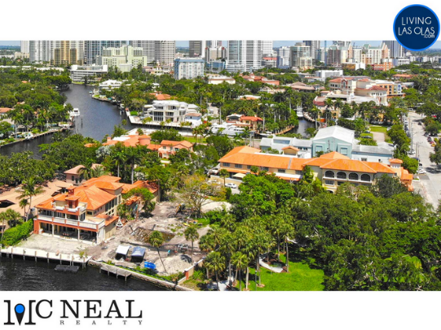 | 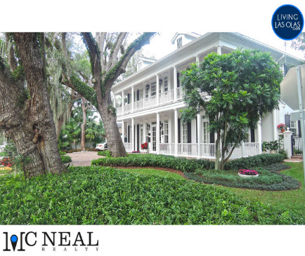 | 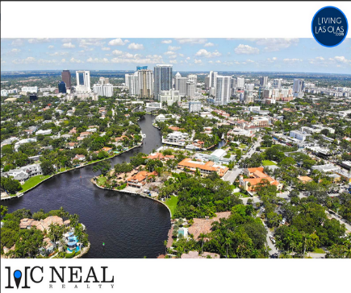
Housing and Zoning:
In general, how old are the buildings? Are the residences single family or multifamily dwellings? Are there track-housing, trailer parks? Are homes in good repair? Abandoned boarded houses?
Notes: Fort Lauderdale encompasses approximately 186,220 population. The building are 40 years old. The residents are single families. The homes are in good repair and there are no abandoned houses.
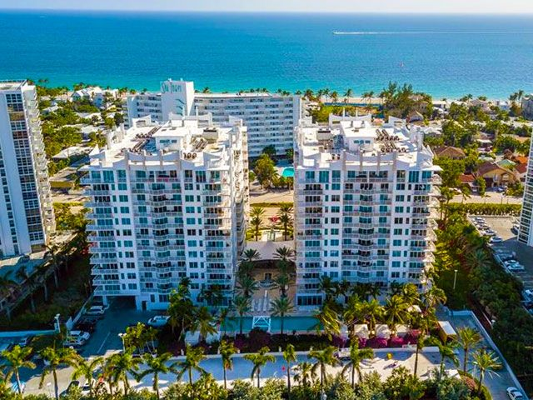 | 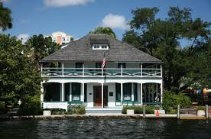 | 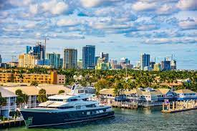
Signs of Decay:
Is the area well maintained or in disrepair? Is there garbage strewn? Are there trashed/abandoned cars, places for rodents or other wildlife to hide, vacant lots?
Notes: the area is well maintained and there is garbage strewn. The area has sewage problems. It has the largest penalty for sewage spill in Florida history. The area has clean and well-maintained parks. Bio-One’s rodent dropping clean-up services specialize in the removal, decontamination and disinfection of animal waste in Fort Lauderdale Area. There are no abandoned building or cars.
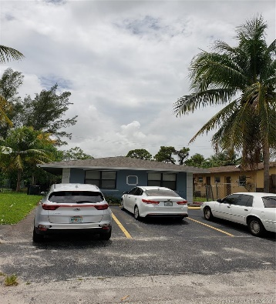
Parks and Recreational Areas:
Are there play areas for children and adults? Are they safe and maintained? Is there any kind of Community Center? Libraries?
Notes: there are playgrounds for children including Hardy park playground and Harbodale playground. They are well maintained. There is community center in Jarvis Hall offering educational programs. In addition, there are libraries-Broward libraries.
Pictures:  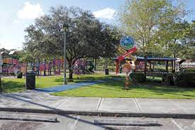 | 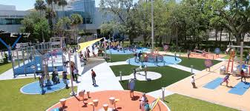 | 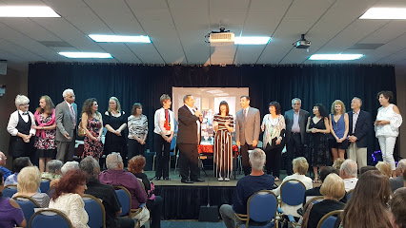
Common Areas:
Where do people collect for social gatherings; where do they “hang out”? Are they for particular groups or are they open to all? Are there signs posted? Is there tagging in the area?
Notes: Social gatherings include united Methodist community Church. Celebrations are done at Conrad fort Lauderdale beach. There are signposts for major social events gatherings. There are popular tags such as #miamipartyboat.
Pictures:  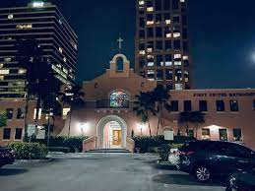 | 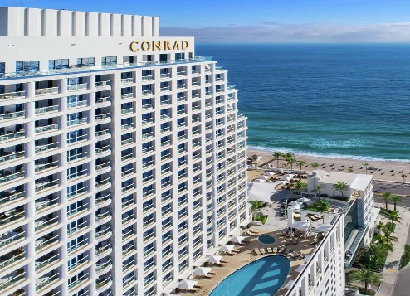
Stores:
What stores (grocery, retail, pharmacy, liquor, smoke shops, dry cleaning, etc.) are in the area? How do residents travel to them?
Notes: the stores include shopping mall, pharmacies, grocery, liquor shops and retail stores.
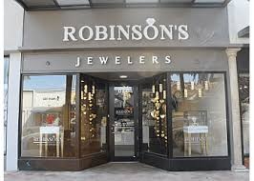 | 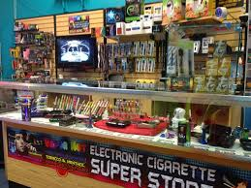 | 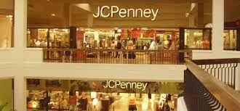
Transportation:
How do most people get around the area? Is there public transportation? If so what kind and does it appear to be used? Who uses it? What is the condition of the streets, roads, highways?
Notes: BCT is a public transport system that takes peoples anywhere they want within the area include working, libraries, parks and cultural activities. The transport service operated fleet of 299 buses on fixed routes. The roads are well maintained and operating smoothly.
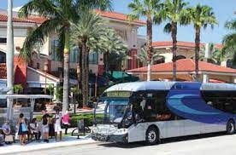 | 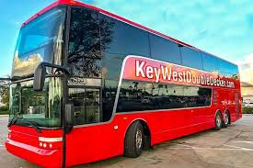
Communication:
Is there evidence of local and national newspapers to other media? Are there informational posters on streets, busses, billboards, etc.?
Notes: there are TV, Radio and Newsletter serving local people in the area. There are clear channels providing billboard advertisement. Posters, digital billboard, bus shelter advertisement and airport advertisement.
Pictures:  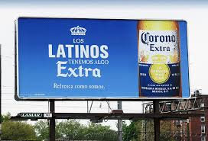 | 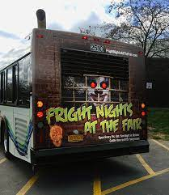
Service Centers:
What services are available in the community – health care, social services, schools, employment offices etc.?
Notes: there are health services including city health and wellness center. Social services include Camelot Community Care Inc. Majors schools include Fort Lauderdale elementary, middle and high schools.
Pictures:  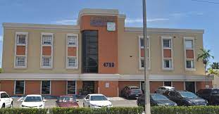 | 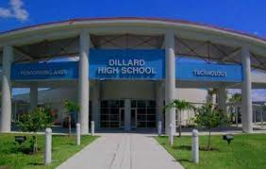 | 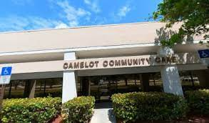
People in the Community:
Who is in the area during the day? What evidence is thereof particular “classes” of people – upper, middle, working, lower?
Notes: there are whites 61.18%, black and African Americans 32.2%, and other races accounting for 2.51%. Most people do not usually take life seriously. The warm weather and the beach proximity reinforce people to curve out of life for themselves in the city. The lifestyle is laid-back and relaxed. There is evidence of 4o% of households in the region are in middle class.
Industries:
What are the major industries located in the area? What types of occupations are evident?
Notes: the major industry in the area is the alliance marine industries. The Yachting Capital of the World is the major marines industry focusing on recreational industry. It is comprised of world-class shipyard, manufacturing, marinas and wholesale/retail products.
Pictures:
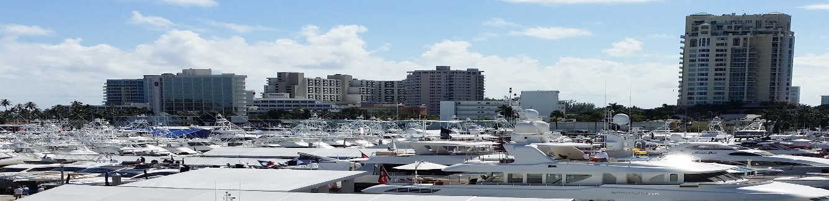
Protective Services:
Where are fire and police stations located? Is there evidence of police and fire protection in the area?
Notes: there is corporate security services offering high real estate security services. The fire protection services providers include Broward fire equipment, service, and black fire protection.
Pictures: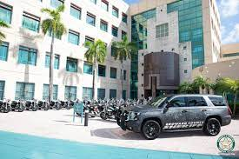 | 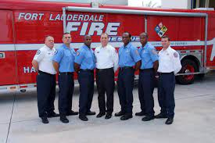
Ethnicity:
What is the predominant ethnic group? Are there residents from a variety of ethnic backgrounds or is the community mostly one group? Which one? Are there stores, restaurants, churches, schools, or languages that indicate a particular ethnic group(s)?
Notes: The predominant racial/ethnic groups are white with 53.3% of all the population. There are also other ethnic groups such as back- 32.1% and Hispanic 18.5%. The Spanish speaks their own language.
Pictures:
Religion:
What churches and church-run schools are in the area (denomination)? How many are there of each denomination?
Notes: there evangelical churches, Christ church school(10), First Baptist Lauderdale(247) and shepherd of coast Lutheran and school(9)
Pictures:  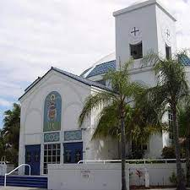 | 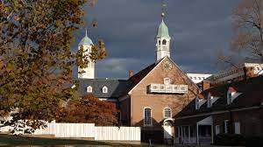 | 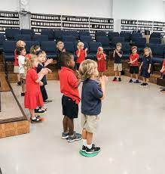
Health and Morbidity:
Is there evidence of any health problems such as drug/alcohol abuse, communicable or chronic diseases, and mental illness (etc)?
Notes: the area has issues with alcohol and drug abuse. Substance use and mental disorder have been increasing for people 12 years and above in the past years. Prevalence of marijuana has been increasing from 2006.
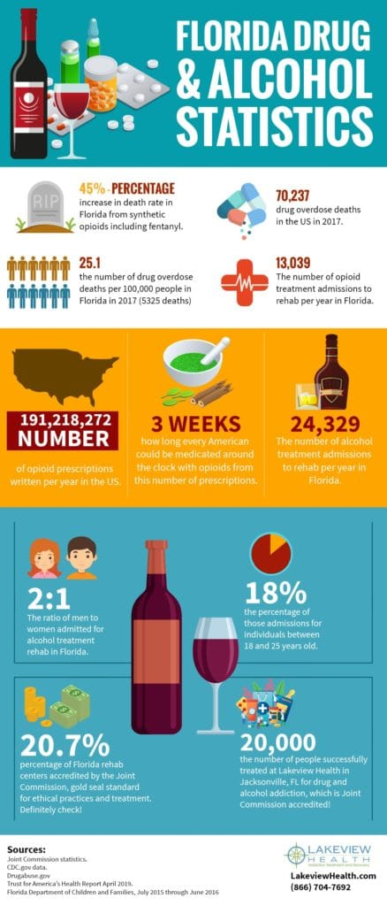
Politics:
Is there evidence of political activity? Are there any signs that indicate a predominant political
Party (parties) or concern(s)? (you may or may not find pictorial evidence of this)
Notes: the predominant party is Florida Democratic Party. 64.5% of people in the area coted for the party while 34.7% voted for republican party.
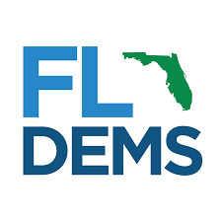 | 